# E:\Users\simon.roche\AppData\Local\Microsoft\Windows\Temporary Internet Files\Content.Word\Evidencing the Impact of the Primary PE and Sport Premium Template 2019 7.3 Images_Page_1.jpg

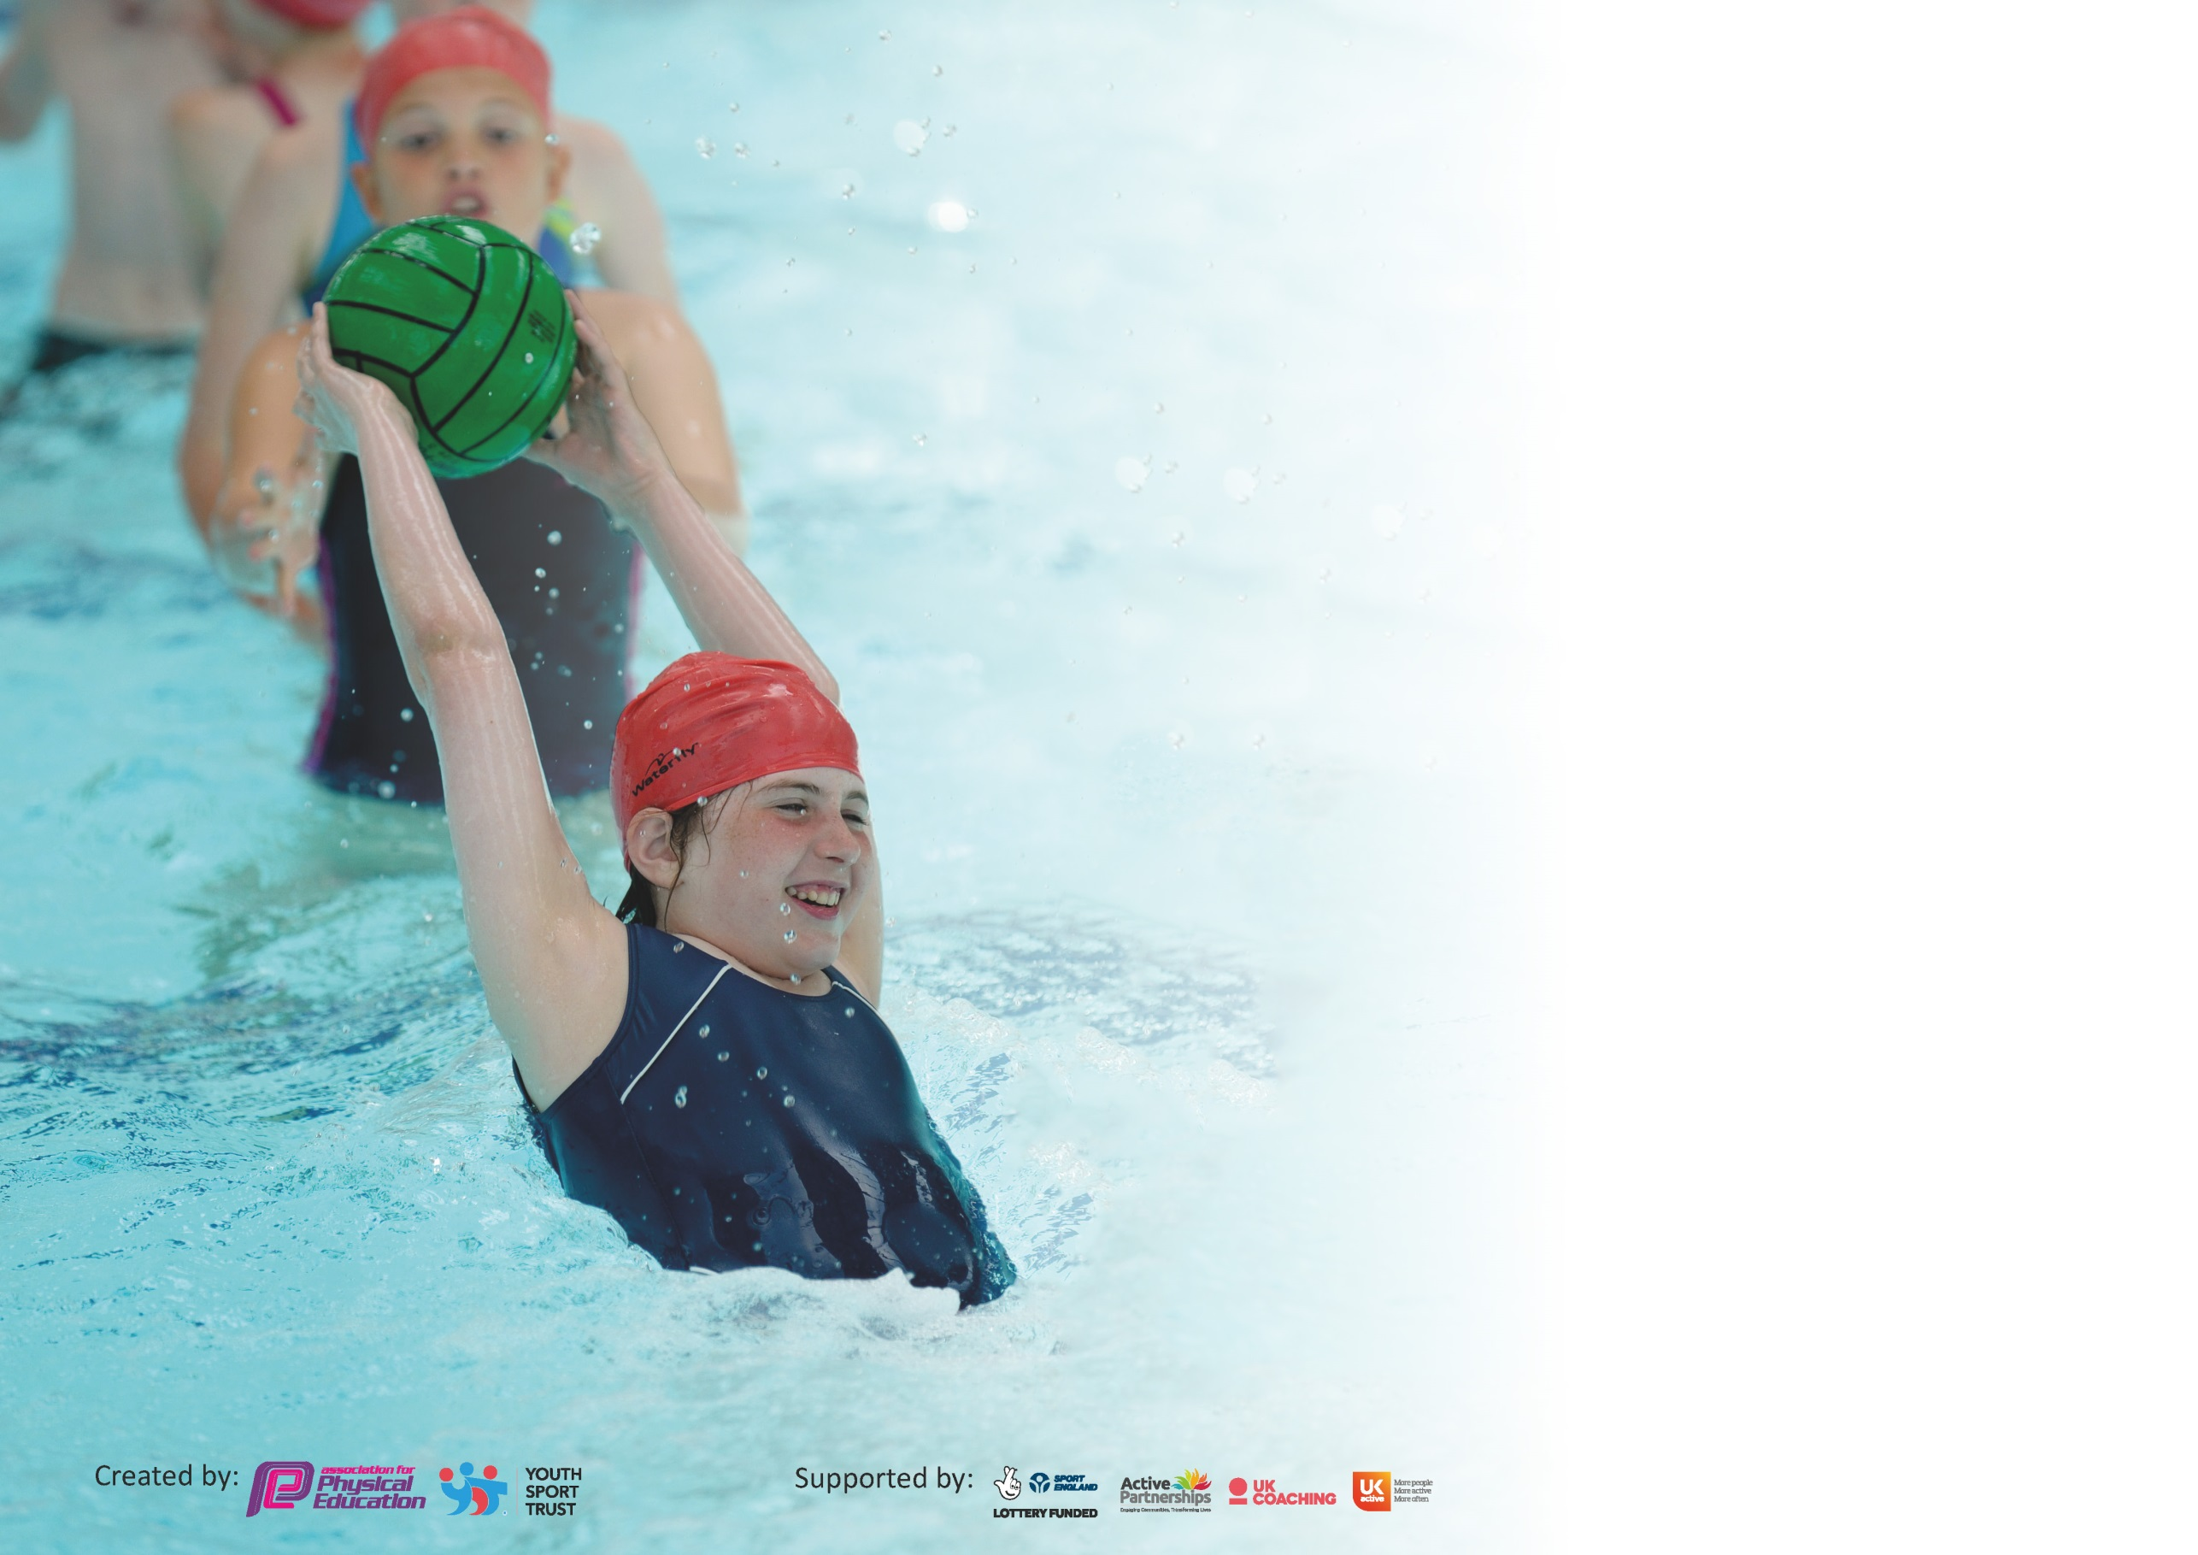

It is important that your grant is used effectively and based on school need. The [Education Inspection Framework](https://assets.publishing.service.gov.uk/government/uploads/system/uploads/attachment_data/file/843108/School_inspection_handbook_-_section_5.pdf) (Ofsted 2019 p64) makes clear there will be a focus on **‘whether leaders and those responsible for governors all understand their respective roles and perform these in a way that enhances the effectiveness of the school’**.

Under the [Quality of Education criteria](https://assets.publishing.service.gov.uk/government/uploads/system/uploads/attachment_data/file/843108/School_inspection_handbook_-_section_5.pdf) (p41) inspectors consider the extent to which schools can articulate their curriculum (INTENT), construct their curriculum (IMPLEMENTATION) and demonstrate the outcomes which result (IMPACT).

To assist schools with common transferable language this template has been developed to utilise the same three headings which should make your plans easily transferable between working documents.

Schools must use the funding to make **additional and sustainable** improvements to the quality of Physical Education, School Sport and Physical Activity (PESSPA) they offer. This means that you should

use the Primary PE and Sport Premium to:

* Develop or add to the PESSPA activities that your school already offer
* Build capacity and capability within the school to ensure that improvements made now will benefit pupils joining the school in future years

Please visit [gov.uk](https://www.gov.uk/guidance/pe-and-sport-premium-for-primary-schools) for the revised DfE guidance including the 5 key indicators across which schools should demonstrate an improvement. This document will help you to review your provision and to report your spend. DfE encourages schools to use this template as an effective way of meeting the reporting requirements of the Primary PE and Sport Premium.

We recommend you start by reflecting on the impact of current provision and reviewing the previous spend.

Schools are required to [publish details](https://www.gov.uk/guidance/what-maintained-schools-must-publish-online#pe-and-sport-premium-for-primary-schools) of how they spend this funding as well as on the impact it has on pupils’ PE and sport participation and attainment by the end of the summer term or by **31st July 2020** at the latest.

We recommend regularly updating the table and publishing it on your website throughout the year. This evidences your ongoing self-evaluation of how you are using the funding to secure maximum, sustainable impact. Final copy must be posted on your website by the end of the academic year and no later than the 31st July 2020. To see an example of how to complete the table please click [HERE](http://www.afpe.org.uk/physical-education/wp-content/uploads/afPE-Example-Template-Indicator-2018-Final.pdf).

Support for review and reflection - considering the 5 key indicators from DfE, what development needs are a priority for your setting and your pupils now and why? Use the space below to reflect on previous spend and key achievements and areas for development.

|  |  |
| --- | --- |
| Key achievements to date until July 2020: | Areas for further improvement and baseline evidence of need: |
| 1. **The engagement of all pupils in regular physical activity**   • Equipment in place to enable children to be active at break and lunchtime  • We continue to have 2 hours of PE curriculum time for all year groups each week.  • The majority of pupils bring their PE kit for lessons.   * Sporting Ambassadors planning activities for break/lunch times * Daily exercise at break times/lunch times  1. **The profile of PE and sport is raised across the school as a tool for whole school improvement.**  * Competitions are celebrated in celebration assemblies * Notice boards in place displaying certificates and information * School Sports Day – competitive event * Using Twitter to share sporting events with parents.  1. **Increased confidence, knowledge and skills of all staff in teaching PE and sport**  * Sports coach to liaise with PE coordinator * Units of Work in place for all PE Lessons  1. **Broader experience of a range of sports and activities offered to all pupils**  * Range of before school and after school clubs on offer to pupils * All year groups have the opportunity to attend sporting events and festivals enabling all children to take part (inclusive of SEN). * Sports coach employed  1. **Increased participation in competitive sport**  * Children involved in sport at a competitive level e.g. Swimming Gala.   Attending a wider variety of sporting events and competitions run by SLSSP | 1. **the engagement of all pupils in regular physical activity**  * Need to take advantage of more national initiatives: e.g. change4life, national fitness day and primary stars, Sport Relief * PE questionnaire – to see children’s participation in regular activity  1. **The profile of PE and sport is raised across the school as a tool for whole school improvement.**  * Membership of SLSSP * Use Twitter to share information * PE Governor to be involved with planning PE opportunities. * Apply for School Games Mark Bronze  1. **Increased confidence, knowledge and skills of all staff in teaching PE and sport**    * Assessment Framework for PE needs developing    * Complete a skills audit to assess further training needs. 2. **Broader experience of a range of sports and activities offered to all pupils**    * Provide more opportunities for KS1 to take part in a wider variety of physical activities 3. **Increased participation in competitive sport**    * Participate in inclusive events.    * Attend local cluster events.    * Participate in events organized by SLSP |

|  |  |
| --- | --- |
| Meeting national curriculum requirements for swimming and water safety. |  |
| What percentage of your current Year 6 cohort swim competently, confidently and proficiently over a distance of at least 25 metres?  **N.B.** Even though your pupils may swim in another year please report on their attainment on leaving  primary school at the end of the summer term 2020. | 100%  NB – 6 Children in Yr6 |
| What percentage of your current Year 6 cohort use a range of strokes effectively [for example, front crawl, backstroke and breaststroke]? | 60%  NB – 6 Children in Yr6 |
| What percentage of your current Year 6 cohort perform safe self-rescue in different water-based situations? | 40%  NB – 6 Children in Yr6 |
| Schools can choose to use the Primary PE and Sport Premium to provide additional provision for swimming but this must be for activity **over and above** the national curriculum requirements. Have you used it in this way? | Yes/No |

**Action Plan and Budget Tracking**

Capture your intended annual spend against the 5 key indicators. Clarify the success criteria and evidence of impact that you intend to measure to evaluate for pupils today and for the future.

|  |  |  |  |  |
| --- | --- | --- | --- | --- |
| **Academic Year:** 2019/20 | **Total fund allocated:** £1650 | **Date Updated: 15th July 2020** | |  |
| **Key indicator 1:** The engagement of all pupils in regular physical activity – Chief Medical Officer guidelines recommend that primary school pupils undertake at least 30 minutes of physical activity a day in school | | | | Percentage of total allocation: |
| % |
| **Intent** | **Implementation** | | **Impact** |  |
| Children are encouraged to be physical by playing physical games, large climbing equipment or running around on field or playground | Children use the pirate ship and adventure play equipment to climb, jump etc. They also use the space for ball games, football and other running games. | No cost | All pupils are active at playtimes/lunchtimes either on the playground, outdoor play equipment or on the school field | Find alternative games during winter or bad weather. |
| Develop Sporting Ambassadors and Games Makers role within school to involve pupils in improving our physical activity levels at school. | Identify Sporting Ambassadors and Games Makers  Children to plan activities to increase physical activity at school at lunchtimes | Part of the SLSP (£2700) | All children active for 30mins every day.  Structured physical activities run by children, designed for all children e.g. Circuits, skipping, fitness, basket ball competitions | Sporting Ambassadors to attend the conference and workshop organized by the Partnership.  Games Makers and Sports Ambassadors to attend a morning training |
| Promote daily physical activity which is not built into the school day for all pupils – national recommendation for 30 minutes everyday | Provision of clubs( before school, lunch times and after school) run by Sports Coach | Sports coach salary  ( £11121) | Cross country club with approx 15 participants across KS2  Football club with approx 8 participants across KS2  **Competitions attended this year:**  *Year 5/6 football games with other schools, Cross Country races at Harborough Leisure Centre, Year 2/3 Tag Rugby, Year 3/4 Unihoc*  **Events attended this year:**  *Sports Ambassador Training x 4 children, Gifted and Talented Sessions x 4 children, GALS Street dance ( Year 4,5 &6), LADS Martial Arts ( Year 4,5 &6), Inclusive PE sessions for SEN children x 10, Multisport, Big Moves Intervention for KS1, Year 3,4 dodge ball* | Continue to provide a variety of clubs  Continue to enter a variety of competitions and events as provided by SLSP  Enter Virtual Competition as provided by SLSP |
| **Key indicator 2:** The profile of PESSPA being raised across the school as a tool for whole school improvement | | | | Percentage of total allocation: |
| % |
| **Intent** | **Implementation** | | **Impact** |  |
| Celebration assembly held regularly to ensure the whole school is aware of the importance of PE, Sport and Physical Activity and to encourage pupils to take part | Achievements are celebrated Children rewarded for sport/ activity effort/ achievement  Groups/ classes invite to demonstrate/ perform  Active travel month for whole school | No cost | Pupils inspired and motivated to take part in sport and activities (registers, feedback)    Pupils are proud of their achievements (photos)  All children involved in active travel month | Continue with weekly assembly  Schedule more active travel occasions |
| Identify Governor to oversee Primary PE and Sport Funding and liaise with PE coordinator to ensure effect plans are in place for pupils to fully benefit from PE, Sport and Physical activity | Meet with Governor to monitor Sports Grant expenditure and Impact | No cost | Primary PE and Sport premium Funding is maximized and compliant with requirements  Activities coordinated through Head and PE coordinator. Monitored on a regular basis by PE governor. | To affiliate with South Leicestershire School Sports Partnership in the next academic year. |
| Establish a Twitter account with parents to share any sporting events such as ‘Sports Days, it’s a Knock Out and general interactive feedback on other sports events. | Teachers to embrace and be active on Twitter account. | No cost | Parents receive photos and information on the latest events. | Develop content and seek parent feedback on improvements that can be made.  Improve information for parent s regarding sporting achievements and events on the school website |
| To ensure that children meet the national curriculum requirements for swimming and water safety. | TA to support specific children to attain this. | ( £2409) | Children meet requirements. |  |

|  |  |  |  |  |
| --- | --- | --- | --- | --- |
| **Key indicator 3:** Increased confidence, knowledge and skills of all staff in teaching PE and sport | | | | Percentage of total allocation: |
| % |
| **Intent** | **Implementation** | | **Impact** |  |
| Ensure Lubenham is up to date with key national and local developments in PE and Sport to ensure pupils can benefit from high quality PE and Sport provision | Attend SL School Sports CPD and Conference | Part of the South Leicestershire School Partnership | School is benefitting from national and local strategies and enabling more pupils to be more active | Continue to sign up to National and Regional Programmes that promote sport and activity |
|  | Attend PE Subject Leader network meetings to liaise with other coordinators |  |  | Affiliate with South Leicestershire School Sports Partnership. |
|  | Share information Leicestershire School Sports Partnership. |  |  |  |
|  | Attend SL School Sports CPD and Conference |  |  |  |
|  |  |  |  |  |
| Assessment Framework for PE needs developing | Find an assessment format to suit both FS/ KS!1/KS2  Inform those teaching PE of Assessment format  Review Assessment format | No cost | Autumn 1 Trust Meeting’s agenda – schools to trail an assessment framework then review together - ongoing | Continue to explore ways to assess PE  Use Sports Coach to assess across the school |
| **Key indicator 4:** Broader experience of a range of sports and activities offered to all pupils | | | | Percentage of total allocation: |
| % |
| **Intent** | **Implementation** | | **Impact** |  |
| Book competitions for different pupils to enjoy participating in throughout the year.  Introduce a range of after school clubs to extend the range of sports and increase participation across the school.  To widen clubs on offer and introduce new sports | Book selective competitions.  Arrange transport and cover  Attend event celebrate participation  **Afterschool Clubs** – multi sports  **New club introduced** – Boxercise  Boxercise equipment purchased | Part of the South Leicestershire School Partnership  Sports coach salary  ( £285) | Participation celebrated at assembly  Children enjoyed the opportunities to compete  In interschool competitions.  Children have been taught new skills and increased physical activity.  Parents have received clubs enthusiastically and it is a key promotional aspect for the school. | Continue to affiliate to the full package of South Leicestershire School sports partnership to compete in further competitions.  To introduce different clubs to offer a wider range of sports. |

|  |  |  |  |  |
| --- | --- | --- | --- | --- |
| **Key indicator 5:** Increased participation in competitive sport | | | | Percentage of total allocation: |
| % |
| **Intent** | **Implementation** | | **Impact** |  |
| Increase pupils participation in the School Games  Need to increase uptake of competitions for SEN organized by SLSP | Identify and book School Games events  Organise training sessions/ club (with staffing)  Attend event celebrate participation | Part of the South Leicestershire School Partnership | Participation celebrated at assembly  SEN children to attend Change 4 Life festival    Six Inclusive PE sessions attended by approx 10 children | Continue to access school games and increase uptake and range of school games events for all children. |

|  |  |
| --- | --- |
| Signed off by | |
| Head Teacher: |  |
| Date: | 10.9.20 |
| Subject Leader: |  |
| Date: |  |
| Governor: |  |
| Date: |  |